Assignment 4 Part 1 Fall 2017
J. Packy Laverty
laverty@rmu.edu
Contents
Assignment 4 – Part 1 Introduction 3
1.0 Introduction to Application Program Development 3
1.1 Questions - Computer Program Language and Computer Algorithms 3
1.2 Questions – Introduction to Programming 5
1.3 Questions - Compilers versus Interpreters 7
1.4 Integrated Development Environment (IDEs) 9
2.0. Program Development Errors and Testing 11
2.1 Questions- Types of Program Errors 11
2.2 Questions- Software Testing 12
3.0 Overview of Programming Languages 13
3.1 Questions - Program Generation Language 13
3.2 Procedural versus Objective Oriented Programming Languages 14
3.3 Questions – C, C++, and C# 15
3.4 Questions - Objective-C and Swift 16
3.5 Questions - PHP 16
3.6 Questions - LAMP, WAMP and MAMP 17
3.7 Questions - Ruby on Rails 18
3.8 Questions – Python, Scala and R 19
4.0 Introduction to COBOL Application Development 20
4.1 Overview of COBOL 20
4.2 Compile, Link and Execute 21
4.3 Questions – Procedural Application Development 24
5.0 Introduction to Android Mobile Application Development 27
5.1 Introduction to Android 27
5.2 Android Components, Messaging and Filters 28
5.3 Comparison of Java and Android API 29
5.4 Security Risks of Native Code 30
6.0 Important Technology Trends 31
6.1 Questions - BYOD 31
6.2 Web Services, Service Oriented Architectures (SOA), and Restful 32
6.3 Questions - The Internet of Things (IoT) 32
6.4 Questions -Software-Defined Applications and Infrastructure 33
6.5 Risk-Based Security, Self-Protection and Context Rich Systems 35

Enter your Name Here

Assignment 4 – Part 1 Introduction
This document contains course content from other instruction handouts to make it easier for you to answer the assignment questions. If you had read these instruction documents, then this assignment will be easier. If you had not read these instruction documents then it is time to catch up with your reading both in terms of the documents and your text book. .

1.0 Introduction to Application Program Development

What Does A Programming Language Do? - http://cplus.about.com/od/introductiontoprogramming/p/programming.htm
Computer Program - http://en.wikipedia.org/wiki/Computer_program
What is a computer algorithm? - http://computer.howstuffworks.com/question717.htm
Algorithm - http://en.wikipedia.org/wiki/Algorithm#Formalization

1.1 Questions - Computer Program Language and Computer Algorithms

1. What is a computer program?
Enter your Answer

2. What is a computer algorithm?
Enter your Answer

3. What are the differences between a computer program and a computer algorithm?
Enter your Answer

Comparing Popular Programming Languages - http://cplus.about.com/od/introductiontoprogramming/a/comparelangs.htm
Definition of Assembly Language - http://cplus.about.com/od/introductiontoprogramming/g/assemblydefn.htm
Assembly Language - http://www.swansontec.com/sprogram.html
What Are Some Advantages/Disadvantages of Using C as compared to Assembly? - http://programmers.stackexchange.com/questions/138924/what-are-some-advantages-disadvantages-of-using-c-over-assembly
ASP.NET - http://en.wikipedia.org/wiki/ASP.NET
Video - What is ASP.NET? - http://www.asp.net/web-forms/videos/how-do-i/what-is-asp-net
Video - http://education-portal.com/academy/lesson/machine-code-and-high-level-languages-using-interpreters-and-compilers.html#lesson

1.2 Questions – Introduction to Programming

(Programming Language, Compilers/Interpreters, SDK and APIs, Prototyping) -
https://www.youtube.com/watch?v=lJnvq0A_7WQ

4. What programming language can be directly understood by the computer without translation in binary code and computer instruction format?
Enter your Answer

5. Which programming language executes very efficiently, easier to program than machine language, and is more power and flexible than higher-level languages like C, C++, COBOL, Java, VB.NET, etc.?
Enter your Answer

6. What popular programming languages would one use to create a Windows device driver?
Enter your Answer

7. What popular open-source scripting programming languages would one use to create web-based server applications?
Enter your Answer

8. What popular open-source scripting programming languages is embedded in an HTML document and executes code on of within a browser client?
Enter your Answer

9. What popular programming languages would one use to create animated graphics, audio, video and special effects on a web page?
Enter your Answer

10. What poplar programming language would one use to create applications that run on multiple platforms and operating systems?
Enter your Answer

11. What object-oriented programming languages are designed to create GUI-based applications for Microsoft operating systems?
Enter your Answer

12. What programming languages are designed to create dynamic web-based applications for Microsoft servers, which may interact with VB.NET or C#.NET applications? (The answer is NOT VB.NET or C#.Net)
Enter your Answer

13. What is a Software Development Kit (SDK)?
Enter your Answer

14. What is an Application Development Interface (API)?
Enter your Answer

15. If you want to write an application that access and interacts with Twitter, Facebook, or Google Apps, one would need to use the appropriate __________ (SDK or API)?
Enter your Answer

16. If you want to write an application that wants to use the hardware of a smart phone, mobile device, or simplifies the coding of web applications one would need to use the appropriate __________ (SDK or API)?
Enter your Answer

17. What is prototyping?
Enter your Answer

18. What is the biggest problem with application programming?
Enter your Answer

19. What is Pseudocode?
Enter your Answer

1.3 Questions - Compilers versus Interpreters
Introduction to Proceedural Application Development

Source Code - http://en.wikipedia.org/wiki/Source_code
Object Code - http://en.wikipedia.org/wiki/Object_code
Translator (computing) - https://en.wikipedia.org/wiki/Translator_(computing)
Types of program translator - https://en.wikibooks.org/wiki/A-level_Computing/AQA/Computer_Components,_The_Stored_Program_Concept_and_the_Internet/Fundamentals_of_Computer_Systems/Types_of_program_translator
What is a computer language translator? - https://www.reference.com/technology/computer-language-translator-1c3fb8a9ee90cfde
Compiler - http://en.wikipedia.org/wiki/Compiler
Interpreter - http://en.wikipedia.org/wiki/Interpreter_(computing)
Advantages and Disadvantages of an Interpreter -
http://wiki.answers.com/Q/What_are_the_advantages_and_disadvantages_of_becoming_a_interpreter

There are three primary types of program translator that are used to translate source program code into object program code: Interpreters, Compilers, and Just-in Time Compliers.

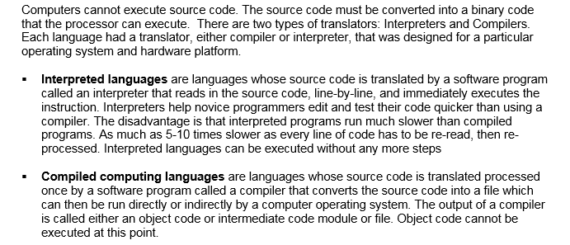

17. What is the function of a Program Language Translator?
Enter your Answer

18. What is Program Source Code?
Enter your Answer

19. What is Object Code?
Enter your Answer

20. Summarize the process that a Program Compiler will use to translate Source Program Code into Object Code.
Enter your Answer

21. Summarize the process that a Program Interpreter will use to translate Source Program Code into Object Code.
Enter your Answer

22. Using the following table list the advantages and disadvantages of using Compilers as a translator.
Advantages | Disadvantages

23. List the advantages and disadvantages of using Interpreters as a translator using the following table.
Advantages | Disadvantages

Many IDEs like Microsoft Visual Studio, Eclipse, Net Beans, XCode, or IBM's RDz will provide both Interpreter and Compiler translators. Interpreters are very useful during the initial coding and testing phases. Some IDEs will highlight syntax or typing errors as they type the source code. But, almost all IDEs will use an Interpreter to execute code (RUN) one line at a time until they encounter an error. At least the developer gets some type of execution. Many IDEs will use the interpreter to "step through" the execution of the program one-line-at-a-time a program to help the programmer debug the error.

However, the limitations of a program interpreter to execute the program are too many, that the program source code will be compiled into a, executable file or load module. When the programmer is finished with application development and testing, the BUILD tool will use the compiler to translate source code into object code and will combine all object code into a, assembly, package or load module to be deployed and executed.

1.4 Integrated Development Environment (IDEs)

Integrated development environment - https://en.wikipedia.org/wiki/Integrated_development_environment

Source code editor- https://en.wikipedia.org/wiki/Source_code_editor
Cloud IDEs For Web Developers - http://www.hongkiat.com/blog/cloud-ide-developers/

24. List several functions Integrated Development Environment (IDE).
Enter your Answer

Source code editor - https://en.wikipedia.org/wiki/Source_code_editor
Video - Notepad Plus Plus - Free Source Code Editor - https://www.youtube.com/watch?v=Pa6H4elNGog
Video - How to use NotePad++ - https://www.youtube.com/watch?v=vl82JFZvrX8

25. Many IDEs provide a Source Code Editor. List and explain some features of a source code editor.
Enter your Answer

Intelligent code completion - https://en.wikipedia.org/wiki/Intelligent_code_completion

26. Many IDEs provide Intelligent Code Completion. List and explain some features of Intelligent Code Completion. (Microsoft Intellisense is a popular Intelligent Code Completion System.)
Enter your Answer

Debugger - https://en.wikipedia.org/wiki/Debugger

Video - Debugging with VisualStudio 2015 - https://www.youtube.com/watch?v=FHnxx99DudI
Video - Debugging with Breakpoints in Visual Studio - https://www.youtube.com/watch?v=7ab4z9u7Q_I

Intelligent code completion - https://en.wikipedia.org/wiki/Intelligent_code_completion

27. Many IDEs provide a Source Code Debugger. List and explain some features of a Source Code debugger.
Enter your Answer

2.0. Program Development Errors and Testing

2.1 Questions- Types of Program Errors

Three Kinds of Programming Errors - http://msdn.microsoft.com/en-us/library/s9ek7a19.aspx
Syntax Errors - http://www.ehow.com/facts_5192875_syntax-error-computer-program_.html
Syntax Errors - http://www.thefreedictionary.com/syntax+error
Syntax Error - http://glossary.spamlaws.com/definition/s/syntax-error.html
Syntax Error - http://dictionary.reference.com/browse/syntax+error

1 What is program syntax?
Enter your Answer

2 What is a program syntax or compilation error?
Enter your Answer

3 Provide an example of a program syntax or compilation error.
Enter your Answer

4 How are program syntax or compilation errors found?
Enter your Answer

Logic Error - http://en.wikipedia.org/wiki/Logic_error
Logic Error - http://wiki.answers.com/Q/What_is_a_logic_error_in_programming

5 What is a program logic or semantic error?
Enter your Answer

6 Provide an example of a program logic or semantic error.
Enter your Answer

7 How are program logic errors found?
Enter your Answer

Run Time Errors - http://en.wikipedia.org/wiki/Run_time_(computing)
Run-time Errors - http://www.webopedia.com/TERM/R/runtime_error.html

8 What is a program run-time error?
Enter your Answer

9. Provide an example of a program run-time error.
Enter your Answer

10 How are program run-time errors found?
Enter your Answer

2.2 Questions- Software Testing

Software testing - http://en.wikipedia.org/wiki/Software_testing
Unit testing - http://en.wikipedia.org/wiki/Unit_testing
Integration testing - http://en.wikipedia.org/wiki/Integration_testing
System testing - http://en.wikipedia.org/wiki/System_testing
Acceptance (user) testing - http://en.wikipedia.org/wiki/Acceptance_testing

Video - Software Testing as a Career - http://www.youtube.com/watch?v=GlLBXGeEcPo
Video - Managers overview of Unit Testing and Mocking - http://www.youtube.com/watch?v=aNhxVFck32A
Video - Software Testing Fundamentals Tutorial for beginners Day 01 - http://www.youtube.com/watch?v=uYa5IhdacjE
Video - Mark Story - Win at life with Unit testing - http://www.youtube.com/watch?v=n-C3fPRnAs4
Video - Integration Testing - http://www.youtube.com/watch?v=yFaKUyTj1vo&list=TLOCUalHy1JOJ3S4VW3TMAqyNQTOiAgkWB
Video - Integration Testing in Software Testing Projects - www.youtube.com/watch?v=yFaKUyTj1vo&list=TLOCUalHy1JOJ3S4VW3TMAqyNQTOiAgkWB
Unit Integration Testing - www.youtube.com/watch?v=yFaKUyTj1vo&list=TLOCUalHy1JOJ3S4VW3TMAqyNQTOiAgkWB
Video - An Introduction to User Acceptance Testing - http://www.youtube.com/watch?v=T6UQrl_HMwY
Video - User Acceptance Testing in Software Testing Projects - http://www.youtube.com/watch?v=aFf2tLzLrDU
Video - System Testing & Acceptance Testing - http://www.youtube.com/watch?v=N8-qNMHOVyw

11. Describe each category of application testing using the following table.
Levels of Application Software Testing | Description of Testing Activities
Unit Testing
Integration Testing
System Testing
Acceptance Testing

3.0 Overview of Programming Languages

3.1 Questions - Program Generation Language

Introduction to Application Programming Document

1. What is the native language and only language that a computer can execute?
Enter your Answer

2. What is assembly language?
Enter your Answer

3. What are the advantages of assembly language?
Enter your Answer

4. What are the disadvantages of assembly language?
Enter your Answer

5. What is meant by one-to-one instruction mapping?
Enter your Answer

6. What is the future of assembly programming language?
Enter your Answer

7. What is are the security risks associated to disassembly or reverse engineering?
Enter your Answer

8. What are the advantages and disadvantage of Abstraction?
Enter your Answer

9. List several examples of third generation programming languages?
Enter your Answer

3.2 Procedural versus Objective Oriented Programming Languages

Introduction to Application Programming Document

Video - The difference between procedural and object-oriented programming - https://www.youtube.com/watch?v=OEfSFrk_KEI

10. What is a Procedural Programming Language?
Enter your Answer

11. What is an Object-oriented Programming Language?
Enter your Answer

12. What is the primary objective (focus) of an Object-oriented Programming Language?
Enter your Answer

3.3 Questions – C, C++, and C#

Advantages and Disadvantages of C Language - http://www.thecrazyprogrammer.com/2013/07/what-are-advantages-and-disadvantages.html
Uses of C - https://www.le.ac.uk/users/rjm1/cotter/page_05.htm
What is C++ used for? - https://www.quora.com/What-is-C++-used-for
Why Code in C Anymore? - http://www.drdobbs.com/cpp/why-code-in-c-anymore/240149452

13. List four uses of the C Programming language?
Enter your Answer

14. List four uses of the C ++ Programming language?
Enter your Answer

15. Compare the performance of C with C ++ programs.
Enter your Answer

16. The most powerful and fastest programming language is assembly language. Why would one use C or C++ programs instead of assembly programs?
Enter your Answer

When to use C#/C++ - http://stackoverflow.com/questions/1251710/when-to-use-c-c
What are the advantages of learning C# over C++? - https://www.quora.com/What-are-the-advantages-of-learning-C-over-C++
For what reasons should I choose C# over Java and C++? http://softwareengineering.stackexchange.com/questions/125712/for-what-reasons-should-i-choose-c-over-java-and-c

17. List four or more reasons why a programmer should use C# as compared to C/C++?
Enter your Answer

18. What type of application programs are written in Fortran?
Enter your Answer

19. What type of application programs are written in COBOL?
Enter your Answer

3.4 Questions - Objective-C and Swift

20. What is the difference between Objective-C and Swift?
YOUR ANSWER IS

3.5 Questions - PHP

Why use PHP to build your Website? - http://www.wolf21.com/blog/why-use-php-to-build-website/
The Top Three Reasons to use PHP - http://php.about.com/od/phpbasics/p/php_reasons.htm
Cross-platform - http://en.wikipedia.org/wiki/Cross-platform

Video - What is PHP? https://www.youtube.com/watch?v=fT7rCWZvsD8
Video - Introduction To PHP - A Complete PHP Tutorial for Absolute Beginners - https://www.youtube.com/watch?v=7UMNz5T-0VQ
Video - PHP Programming Part 1: Introduction to PHP Programming - https://www.youtube.com/watch?v=27dR_sLaM74&list=PL6C3CB409A8577C2F
Video - PHP Programming Part 2: PHP Syntax and Errors - https://www.youtube.com/watch?v=L0pgyxOAdlg&list=PL6C3CB409A8577C2F
Video - PHP Programming Part 3: Comments and INCLUDE in PHP Programming - https://www.youtube.com/watch?v=LLSKQbKbaVg&list=PL6C3CB409A8577C2F

Video - LAMP and WAMP - https://www.youtube.com/watch?v=tJoVPDLSIR8
Video - What is the LAMP Stack? - https://www.youtube.com/watch?v=WY8jwTNYTfg
Video - How to install WAMP server on windows - https://www.youtube.com/watch?v=kVc_9vAO7oI
Video - Introduction to PHP - Day 1 - Server setup and Hello World - https://www.youtube.com/watch?v=QU5kUrt2lN0

21. What is PHP the programming language used for, e.g., system programming, application development, dynamic web page applications, etc.?
YOUR ANSWER IS

3.6 Questions - LAMP, WAMP and MAMP

22. The PHP programming language is often bundled with other products, e.g., LAMP? What does the acronym LAMP mean?
YOUR ANSWER IS

23. The PHP programming language is often bundled with other products, e.g., WAMP? What does the acronym WAMP mean?
YOUR ANSWER IS

24. List several reasons why a programmer should use PHP?
YOUR ANSWER IS

25. What Is PHP platform independent like Java?
YOUR ANSWER IS

3.7 Questions - Ruby on Rails

Video - What is Ruby on Rails? - https://www.youtube.com/watch?v=yEmHb4Vu77w
Video - How to install Ruby on Rails on Windows 7 - Part 1, Initial setup - https://www.youtube.com/watch?v=-eFwV8lRu1w
Video - How to install Ruby on Rails on Windows 7 - Part 2, Ruby - https://www.youtube.com/watch?v=D-YikrZqfbY
Video - How to install Ruby on Rails on Windows 7 - Part 3, MySQL connector - https://www.youtube.com/watch?v=y0X7SUfF928
Video - How to install Ruby on Rails on Windows 7 - Part 4, Ruby on Rails - https://www.youtube.com/watch?v=hy5x8aGKrrw
Video - Introduction to Ruby - Day 1 - Rubymine setup - Hello World - https://www.youtube.com/watch?v=1lgu_l4oe8c&list=PLSXDqiI4sC5NinJXEoYH6FYQ7vtIO8IPF

Video - Python vs PHP Comparison - https://www.youtube.com/watch?v=ufmzc2sDmhs

Five Reasons Why We Use Ruby on Rails - http://www.infront.com/blogs/the-infront-blog/2013/1/4/five-reasons-why-we-use-ruby-on-rails
When to use Ruby on Rails? - http://www.slideshare.net/dosire/when-to-use-ruby-on-rails-1308900
20 Reasons Why Every Web Designer Needs to Learn Rails - http://blog.teamtreehouse.com/reasons-why-every-web-designer-needs-to-learn-rails

26. What is Ruby on Rails programming language used for, e.g., system programming, application development, dynamic web page applications, etc.?
YOUR ANSWER IS

27. List several reasons why a programmer should use Ruby on Rails?
YOUR ANSWER IS

28. Is Ruby on Rails platform independent like Java?
YOUR ANSWER IS

29. Is Ruby on Rails more similar to the C programing language or PHP programming language?
YOUR ANSWER IS

3.8 Questions – Python, Scala and R

Video - Is Python Beginner Friendly? - https://www.youtube.com/watch?v=ryU5SVXO4Q0
Video - Python Programming in 15 Minutes - https://www.youtube.com/watch?v=yk022Kz8zqg
Video Cartoon - Should I Learn Java or Python? https://www.youtube.com/watch?v=epXQMbnmlcY
Video - Python Programming - Introduction - https://www.youtube.com/watch?v=72RKMMyLxS8
Video - You Used Python for What?! - https://www.youtube.com/watch?v=NLRWUQDaApw

Why We Choose Python? - http://www.sixfeetup.com/blog/why-we-choose-python
Why use Python as compared to other programming languages? http://www.reddit.com/r/Python/comments/1bqv85/why_do_you_choose_python_over_other_language/
Why do you use python? - https://groups.google.com/forum/#!topic/comp.lang.python/ZsyxDS2lt0A

30. What are the advantages of using Python as the programming language for system programming, application development, dynamic web page applications, etc.?
YOUR ANSWER IS

31. List several reasons why a programmer should use Python?
YOUR ANSWER IS

32. Is Python platform independent like Java?
YOUR ANSWER IS

32. Is Python platform independent like Java?
YOUR ANSWER IS

31. What are the advantages of using the Scala program language to develop Data Analytic applications?
YOUR ANSWER IS

32. What is a Functional Programming Language?
YOUR ANSWER IS

33 List four or more comparisons of Scala to Java.
YOUR ANSWER IS

34. Compare the use of Python and Scala programming languages if developing batch (Hadoop) and real-time (Spark) data analytic applications.
YOUR ANSWER IS

35. Python has its own statistical analysis library. Scala does not. How does Scala perform statistical processing to for data analytic applications?
YOUR ANSWER IS

3.6 What are the advantages of using Rexx?
YOUR ANSWER IS

4.0 Introduction to COBOL Application Development

Important Video - COBOL Application Development Part 1 - http://youtu.be/MiLlSz8hnOc
Important Video - COBOL Application Development Part 2 - http://youtu.be/ozXKLwRwuOo

4.1 Overview of COBOL

Using Programming Languages on z/OS - Chapter 9. Introduction to the New Mainframe: Z/OS Basics
Compiling and Link-editing a Program on z/OS - Chapter 10. Introduction to the New Mainframe: Z/OS Basics

COBOL History http://www.mainframegurukul.com/tutorials/programming/cobol/cobol-history.html
COBOL Program Structure http://www.mainframegurukul.com/tutorials/programming/cobol/cobol-program-structure.html
COBOL – Overview - http://www.tutorialspoint.com/cobol/cobol_overview.htm

The COBOL (Common Business Oriented Language) was introduced by IBM in 1959 as third generation programming language. COBOL has changed and improved several times. While some will state that ANSI COBOL-85 is the current version of COBOL this is not exactly accurate. COBOL-85 is the minimum requirements for COBOL and the actual syntax and rules vary by the company who made the COBOL compiler.

For example, the current COBOL compiler being used on IBM mainframes is called Enterprise COBOL for z/OS version 5, which replaced VS COBOL II. However, the actual version of IBM COBOL will depend on the actual operating system, e.g., MVS, AIX, etc. as well as COBOL versions on Linux and Windows Platforms. Unlike Java and .NET, COBOL is NOT platform independent. The latest IBM COBOL compiler will also help integrate business logic written in COBOL with web and mobile user interfaces by providing interoperability with XML and Java.

COBOL was designed to support business applications that need to 1) efficiently interface with data files, data sets, and databases, 2) minimize memory usage (small foot print), and 3) efficiently use processor resources. On average, a compiled COBOL application uses, on the average, 15% less memory and 40% less processing time compared to a Java module with the same business requirements. However, COBOL is not platform independent, is not designed to support all modern user interfaces, has very limited advanced mathematics functions and ability to communicate outside its address space.

When COBOL cannot perform an application requirement on the mainframe, this limitation may be overcome by simply writing an Assembly Language program. IBM COBOL and IBM Assembler were made to work together, taking into consideration the advantages of each language.

Java was designed to be a platform independent, object-oriented programming language, designed to promote re-usability of source or byte-code, to easily add new features to the program language. Those advantages come with a substantial processing overhead. C was designed as a high-level programming language to be as powerful and flexible as the assembler programming language. But unlike COBOL, a powerful and flexible programming language creates security concerns.

4.2 Compile, Link and Execute

The traditional steps for developing a computer program after determining the program requirements (what do you want the program to do?) are: 1 Write the computer source code using some type of editor, 2) Translating the code into object code using either Interpreters, Compilers, and Just-in Time Compliers, 3) Linking the object to a load library which contains pre-written routines applicable to your operating system, 4) store an executable program file, and then load and execute the executable file by either entering the file name, clicking on an icon or short-cut, etc. The following diagram provides and overall view of the process.

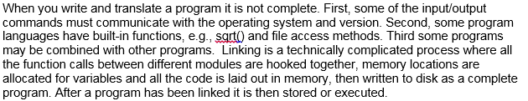

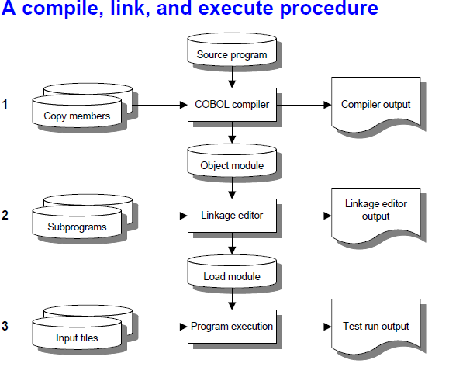

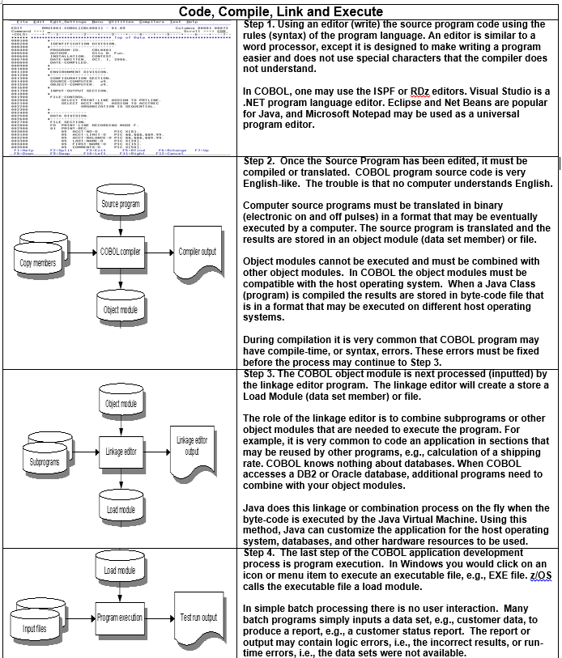

4.3 Questions – Procedural Application Development

Load Modules - https://chortle.ccsu.edu/AssemblyTutorial/Chapter-01/ass01_14.html

1. What are the differences between an object module and a load module?
Enter your Answer

2. What is the name of the program or utility that converts source code into object code?
Enter your Answer

3. Lists the steps of the COBOL Application Development Process (which is similar to all procedural programming languages)?
Enter your Answer

4. What are the functions of a Linkage editor or Linker in the application development process?
Enter your Answer

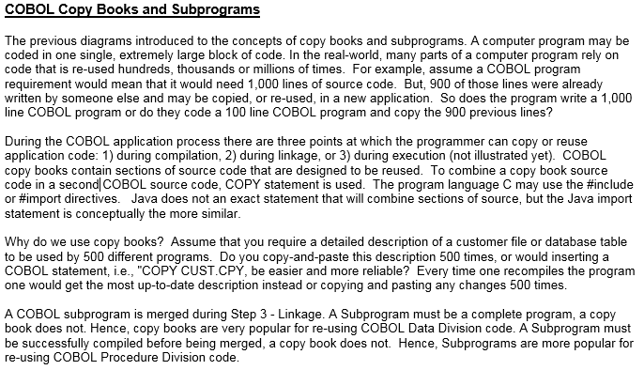

5. What are the functions of a COBOL Copy Book?
Enter your Answer

6. What is a COBOL Subprogram (which is similar to a C Language include file and a Java External Class)?
Enter your Answer

7. Why should a COBOL programmer use COBOL copy books and subprograms?
Enter your Answer

8. Which step of the application development process is a subprogram merged with the main program?
Enter your Answer

9. Which step of the application development process is a copy book merged with the main program?
Enter your Answer

10. Which step of the application development process that a program interacts with files, users, client internet browsers and databases?
Enter your Answer

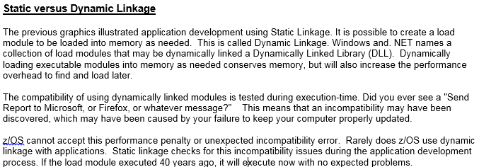

11. What are the differences between Static Linkage and Dynamic Linkage?
Enter your Answer

12. What is the function of a Windows DLL file?
Enter your Answer

13. Which legacy programming language processes the most business transactions and interactions with database management systems?
Enter your Answer

5.0 Introduction to Android Mobile Application Development
Comparative Analysis of Application Development and Security Models - Read this assignment attached paper.

Vulnerabilities and Threats to Mobile Application Security from a Practitioner Approach - Read this assignment attached paper.

5.1 Introduction to Android

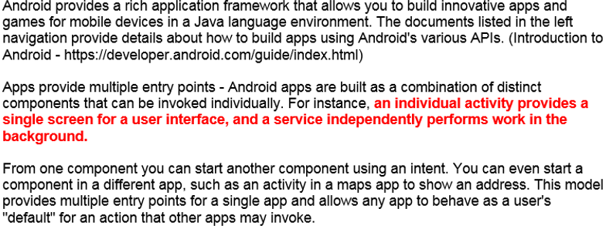

5.2 Android Components, Messaging and Filters

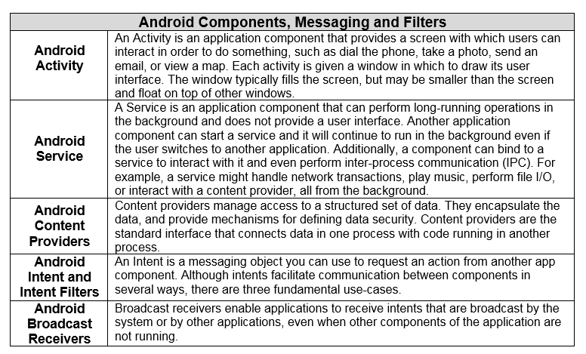

5.3 Comparison of Java and Android API

Comparison of Java and Android API - http://en.wikipedia.org/wiki/Comparison_of_Java_and_Android_API
Android, Java, and the tech behind Oracle v. Google (FAQ) - http://www.cnet.com/news/android-java-and-the-tech-behind-oracle-v-google-faq/

1. What are the differences between the Java programming language and Android? Answer =>

2. Which company supports the Open-source Android API? Answer =>

3. Which company supports the Open-source J2SE API? Answer =>

4. What is an Android Project? Answer =>

5. What is function the Android Layout Manager? Which popular Java API did the Android Layout Manger replace? Answer =>

Special note: If you haven't read the paper titled "Comparative Analysis of Application Development and Security Models" you are probably pulling your hair out by now.

5.4 Security Risks of Native Code

6. Which programming languages are specified as "native code" programming languages? Answer =>

7. List several security risks associated with "native code" programming languages using the following table.
Security Risks Associated with Native Code Programming Languages
1.

2.

3.

4.

5.

8. What is managed code? Answer =>

9. Despite the security risks of native code programming languages, why does the Android Platform support these languages? Answer =>

10. Describe how the Android Platform supports native code programming languages. Answer =>

Assume that you are coding an Android App your first that will permit students rate RMU courses, e.g., the amount of work required, the difficulty of tests, amount of reading, and availability of previous assignments and tests to copy. This app, called the RMU COURSE APP. will store the course information and ratings in a database to be used for later analysis. Answer the following questions.

11. Provide a SPECIFIC descriptive example of when you would want to code an Android Activity. Answer =>

12. Provide a SPECIFIC descriptive example of when you would want to code an Android Service . Answer =>

6.0 Important Technology Trends

There are several technology trends that are dominating the focus of new projects in Business and Government. These new technology trends will affect the role and skills required for system analysts, project managers, and software engineers. Several of these new technology trends are discussed in the following section. You will be required to demonstrate your basic knowledge and apply these technologies to project example using your personal examples with your organization or to some organization that you have researched.

6.1 Questions - BYOD

Mobile interface in diverse contexts and environments as opposed to focusing on devices alone or consumer roles. For example, the trend to introduce BYOB/ BYOT in the workplace or public space will continue to raise significant management challenges for IT organizations as they lose control of user endpoint devices. It will also require increased attention to user experience design.

What is bring your own device? http://www.ibm.com/mobilefirst/us/en/bring-your-own-device/byod.html
Bring your own device- https://en.wikipedia.org/wiki/Bring_your_own_device
Pros and Cons of Bringing Your Own Device to Work - http://www.pcworld.com/article/246760/pros_and_cons_of_byod_bring_your_own_device_.html

1. What is BYOD or BYOT? Answer =>

2. List the advantages and disadvantages of BYOD/BYOT using the following table.

Advantages and Disadvantages of BYOD/BYOT Projects In Business and Government
Advantages | Disadvantages

3. Using your personal example or an example from your current or previous employer, specifically describe a projects requirements, potential benefits (pros) and costs (cons) for a BYOD project. Answer =>

6.2 Web Services, Service Oriented Architectures (SOA), and Restful
Batch Processing has no user interface. OLTP system interface with a commercial, consumer or other user. Web services was constructed to have one computer program or electronic device to use the services of another computer program or electronic device, no matter what the programming language, operating system, or physical location of the computer program. The flexibility to design programs to communicate with each other is call interoperability.

Many web services are often started by a user request. For example, the travel site named Kayak, permits a user to input flight information which queries the databases of various airline reservations using web services. This is only one example, called a metasearch engine, of the many which use web service applications. This process can also query hotel reservation systems or car rental systems.

Web services can be implemented by two different programming approaches: traditional SOAP-based web services and Restful-based web services. While both technologies have value those systems that rely on web-based user transaction are be transitioned to the easier-to-use and more powerful Restful-based technologies.

It is important to notice that 70% of new application programming hires require knowledge or SOAP.

6.3 Questions - The Internet of Things (IoT)

Internet of Things devices, applications & examples - http://www.businessinsider.com/internet-of-things-devices-applications-examples-2016-8
5 Easy To Understand Examples Of The Internet of Things - https://www.forbes.com/sites/blakemorgan/2016/01/27/5-easy-to-understand-examples-of-iot-and-customer-experience/#4a6624eb366c
Rise of the machines: who is the ‘internet of things’ good for? - https://www.theguardian.com/technology/2017/jun/06/internet-of-things-smart-home-smart-city
The advantages and disadvantages of Internet of Things - https://e27.co/advantages-disadvantages-internet-things-20160615/
Pros and Cons of Internet of Things (IoT) - What You Need to Know - https://www.buzzle.com/articles/pros-and-cons-of-internet-of-things-iot.html

The Internet is expanding beyond PCs and mobile devices into enterprise assets such as field equipment, and consumer items such as cars and televisions. The problem is that most enterprises and technology vendors have yet to explore the possibilities of an expanded Internet and are not operationally or organizationally ready.

Imagine digitizing the most important products, services and assets. The combination of data streams and services created by digitizing everything creates four basic usage models – manage; monetize; operate; extend. These four basic models can be applied to any of the four "Internets” (people, things, information and places). Enterprises should not limit themselves to thinking that only the Internet of Things (i.e., assets and machines) has the potential to leverage these four models. Enterprises from all industries (heavy, mixed, and weightless) can leverage these four models

A sensor is not a machine. It doesn’t do anything in the same sense that a machine does. It measures, it evaluates; in short, it gathers data. The Internet of Things really comes together with the connection of sensors and machines. That is to say, the real value that the Internet of Things creates is at the intersection of gathering data and leveraging it. All the information gathered by all the sensors in the world isn’t worth very much if there isn’t an infrastructure in place to analyze it in real time.

1. Provide a detailed definition of the Internet of Things (IoT). Answer =>

2. Provide a detailed example of Internet of Things (IoT) that will affect your home. Answer =>

3. Provide a detailed example of Internet of Things (IoT) that will affect your workplace. Answer =>

4. Provide a detailed example of Internet of Things (IoT) that will affect public utilities, e.g., the elective grid, your cable T.V., etc. Answer =>

5. List three or more advantages of IoT technologies. Answer =>

6. List three or more disadvantages of IoT technologies. Answer =>

6.4 Questions -Software-Defined Applications and Infrastructure

Software-defined networking (SDN) - http://searchsdn.techtarget.com/definition/software-defined-networking-SDN
7 Advantages of Software Defined Networking - http://www.ingrammicroadvisor.com/data-center/7-advantages-of-software-defined-networking
What SDN is and where it’s going - https://www.networkworld.com/article/3209131/lan-wan/what-sdn-is-and-where-its-going.html
Eight Big Benefits of Software-Defined Networking - https://www.serverwatch.com/server-tutorials/eight-big-benefits-of-software-defined-networking.html
What are the disadvantages of software-defined networking? - https://www.quora.com/What-are-the-disadvantages-of-software-defined-networking
Video - What is a Software Defined Network - https://www.youtube.com/watch?v=lPL_oQT9tmc

Software-defined anything (SDx) is a collective term that encapsulates the growing market momentum for improved standards for infrastructure programmability and data center interoperability driven by automation inherent to cloud computing, DevOps and fast infrastructure provisioning. As a collective, SDx also incorporates various initiatives like OpenStack, OpenFlow, the Open Compute Project and Open Rack, which share similar visions. As individual SDx technology silos evolve and consortiums arise, look for emerging standards and bridging capabilities to benefit portfolios, but challenge individual technology suppliers to demonstrate their commitment to true interoperability standards within their specific domains.
While openness will always be a claimed vendor objective, different interpretations of SDx definitions may be anything but open. Vendors of SDN (network), SDDC (data center), SDS (storage), and SDI (infrastructure) technologies are all trying to maintain leadership in their respective domains, while deploying SDx initiatives to aid market adjacency plays. So vendors who dominate a sector of the infrastructure may only reluctantly want to abide by standards that have the potential to lower margins and open broader competitive opportunities, even when the consumer will benefit by simplicity, cost reduction and consolidation efficiency.
1. Explain the function or purpose of Software Defined Networking Technologies. Answer =>

2. List two or examples of computer technologies which the trend of SDN would improve network services. Answer =>

3. List two or examples of computer technologies which the trend of SDN would NOT improve network services. Answer =>

4. List three or more benefits of SDN technologies. Answer =>

5. List three or more dis advantages of SDN technologies. Answer =>

6. List three or more disadvantages of IoT technologies. Answer =>

6.5 Risk-Based Security, Self-Protection and Context Rich Systems

Organizations will increasingly recognize that it is not possible to provide a 100 percent secured environment. Once organizations acknowledge that, they can begin to apply more-sophisticated risk assessment and mitigation tools. On the technical side, recognition that perimeter defense, e.g., firewalls, IDSs, etc., is inadequate and applications need to take a more active role in security gives rise to a new multifaceted approach. Security-aware application design, dynamic and static application security testing, and runtime application self-protection combined with active context-aware and adaptive access controls are all needed in today's dangerous digital world. This will lead to new models of building security directly into applications. Perimeters and firewalls are no longer enough; every app needs to be self-aware and self-protecting.

Security-aware application design, dynamic and static application security testing, and runtime application self-protection combined with active context-aware and adaptive access controls are all needed in today’s dangerous digital world. This will lead to new models of building security directly into applications. Perimeters and firewalls are no longer enough; every app needs to be self-aware and self-protecting.
Context-Rich Systems

Ubiquitous embedded intelligence combined with pervasive analytics will drive the development of systems that are alert to their surroundings and able to respond appropriately. Context-aware security is an early application of this new capability, but others will emerge. By understanding the context of a user request, applications can not only adjust their security response but also adjust how information is delivered to the user, greatly simplifying an increasingly complex computing world.

In today’s hacker filled world, context aware security solutions are extremely important as organizations seek to encourage collaboration with employees and non-employees alike, across disparate networks, systems and devices. Solutions that provide sophisticated identity and access management capabilities by looking at users and their context, to dynamically provide secure access to systems, applications and content are necessary to protect your business and most important asset- it’s data.

This approach combines both classification and document level encryption to effectively secure and control content. Using this unique combination of content, context and identify aware security allows you to monitor for all types of content uses across your organization. It offers the most comprehensive approach for secure collaboration.

